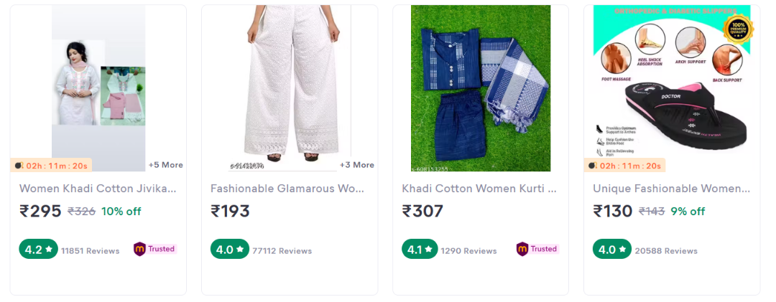.
- Create card as it is do not add Time, Trusted symbol and do not add review count in it.
- It should only contain Image, Name, Price, Rating and cut amount with off.
- Use previous project (dental solution, CSS) for flex or gride.
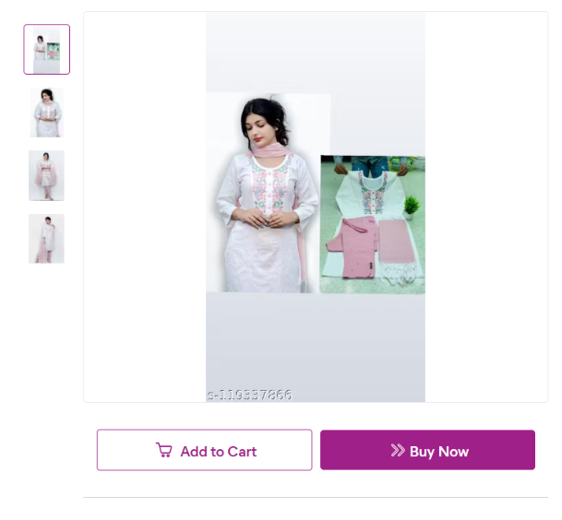
- In left side the 4 images are in due tag and has a onclick border effect with image change on main poster.
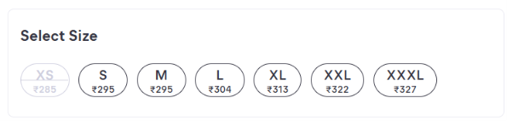
- Use ai to build this just make it in frontend

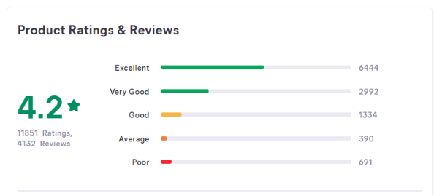.
- We will only add Number of rating.
- And no Real Images and videos from customers.

